H.T No
Regulations:
A15


Sreenidhi Institute of Science and Technology
(An Autonomous Institution)
Code No: 5K704 Date: 12-Dec-2019 (AN)

B.Tech IV-Year I-Semester External Examination, December - 2019 (Regular)
FINITE ELEMENT METHOD FOR CIVIL ENGINEERS (CIVIL)

Time: 3 Hours Max.Marks:75

Note: a) No additional answer sheets will be provided.
b) All sub-parts of a question must be answered at one place only, otherwise it will not be valued.
c) Missing data can be assumed suitably.

Part - A Max.Marks:25

Answer all QUESTIONS.

1. | Explain the basic principle used in FEM. | [3M]
2. | What is the expression for an element stiffness matrix of a truss in local coordinate system? | [3M]
3. | What is the condition for number of unknown polynomial coefficients of a 2-D element? | [3M]
4. | Define fins or extended surfaces. | [3M]
5. | What is a shape function? | [3M]
6. | Differentiate linear shape functions with quadratic shape functions. | [2M]
7. | Write the equilibrium equations for an elemental volume dv = dxdydz.. | [2M]
8. | What is a two dimensional element? | [2M]
9. | Explain the following with examples:  i) Lumped parameter model. ii) Continuous system model. | [2M]
10. | What do you mean by iso-parametric formulation? | [2M]
Part – B Max.Marks:50
ANSWER ANY FIVE QUESTIONS. EACH QUESTION CARRIES 10 MARKS.

11. | a) | Using variational approach (potential energy), describe FE formulation for 1D bar element. | [5M]
 | b) | Using potential energy approach, describe FE formulation for plane truss Element | [5M]
12. | a) | Derive the Stiffness matrix for a 3D truss Element. | [5M]
 | b) | Determine the deflection and slope under the point load for the beam shown in fig given. E=200 GPa, I= 4 x 10⁻⁶m⁴, I₂=2 x 10⁻⁶m^{4.}  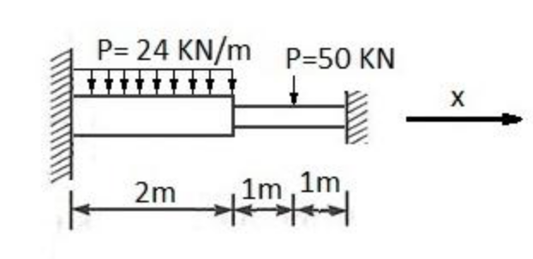 | [5M]
13. | a) | Formulate the finite element equations for the element shown in fig. E=200Gpa, ν.=0.3, thickness=5mm,p₁=5N/mm² acting on side jk and along x –direction P₂=2N/mm²acting along on the side and perpendicular to the side ik. use plane stress condition.  X_{i} =1 X_{j}=6 X_{k}=3  Yi=1 Y_{j}=4 Y_{j}=5  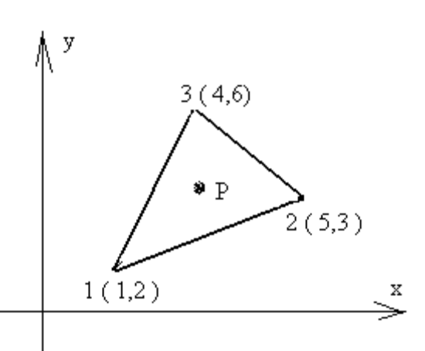 | [5M]
 | b) | Derive the strain displacement matrix for triangular element. | [5M]
14. | a) | Explain the overall procedure for solving a structural engineering problem using ANSYS software. | [5M]
 | b) | Determine the circumference of a circle of radius ‘r’ using the basic principles of ﬁnite element method. | [5M]
15. | a) | Derive the one point Gauss quadrature formula of numerical integration. | [5M]
 | b) | A continuous beam shown below carries a 10 kN/m distributed load on one of the 1 m span as shown in the below figure. Calculate the vertical deﬂection at the mid point of the distributed load using FEM modelling. E = 200 Gpa, A = 500 mm², I = 2 X 10⁶ mm⁴.  10 kN/m  1 m  1 m | [5M]
16. | a) | Evaluate natural frequencies for the cantilever beam using one element. | [5M]
 | b) | Distinguish between consistent mass matrix and lumped mass matrices. | [5M]
17. | a) | State Minimum potential energy principle and write the general expression for potential energy for elastic loaded bodies. | [3M]
 | b) | Calculate displacement vector, stresses, and reactions for the following Structure.  Take E = 2 X 10⁵ N/mm². [Either Penalty or Elimination method can be used for boundary condition]  200 mm  200 mm  A₁=300 mm²  A₂=100 mm²  400 kN  400 kN | [4M]
 | c) | Determine the shape functions for a 8 node quadratic quadrilateral element(boundary noded) | [3M]
18. | a) | Discuss the importance of iso parametric conditions in solving the CST problems | [4M]
 | b) | Evaluate ∫〖(ξ〗^2 +ξη)dA over the CST (three-node triangular element) with node 1 at (0,0), node 2 at (1,0), node 3 at (0,1) using one-point Gauss quadrature. | [3M]
 | c) | Derive the elemental mass matrix for 1-D bar element and 1-D plane truss element. | [3M]

-- 00 -- 00 –

